1. Source Code

* Controller 🡪 Perkenalan.php

1. URL :

<http://localhost:8888/ci_hadi/index.php/perkenalan>

1. 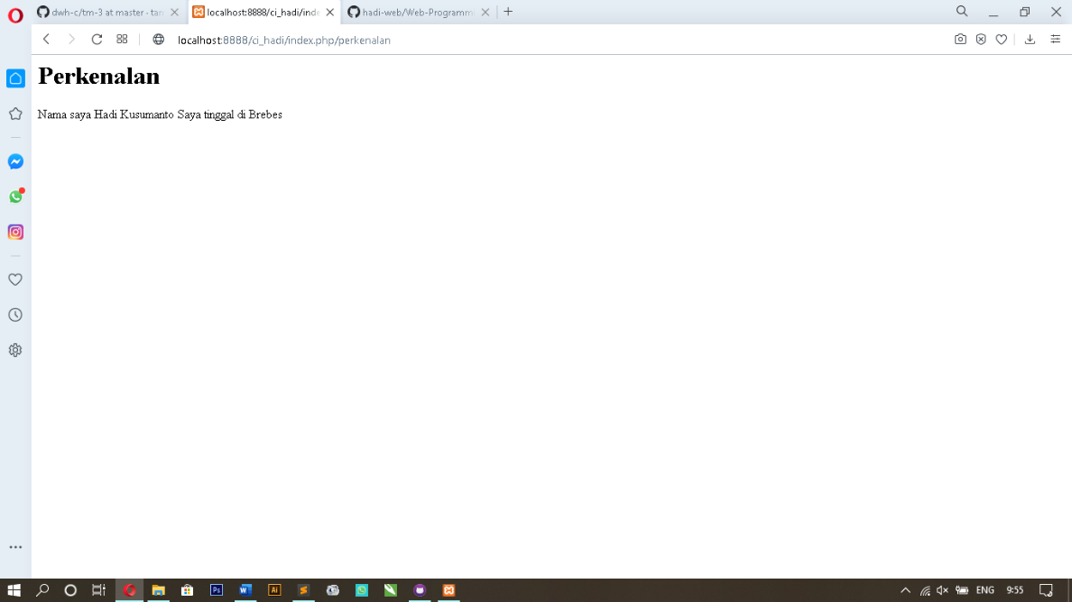Screen Shoot